SECTION A- Entity Relationship Diagram (ERDs)
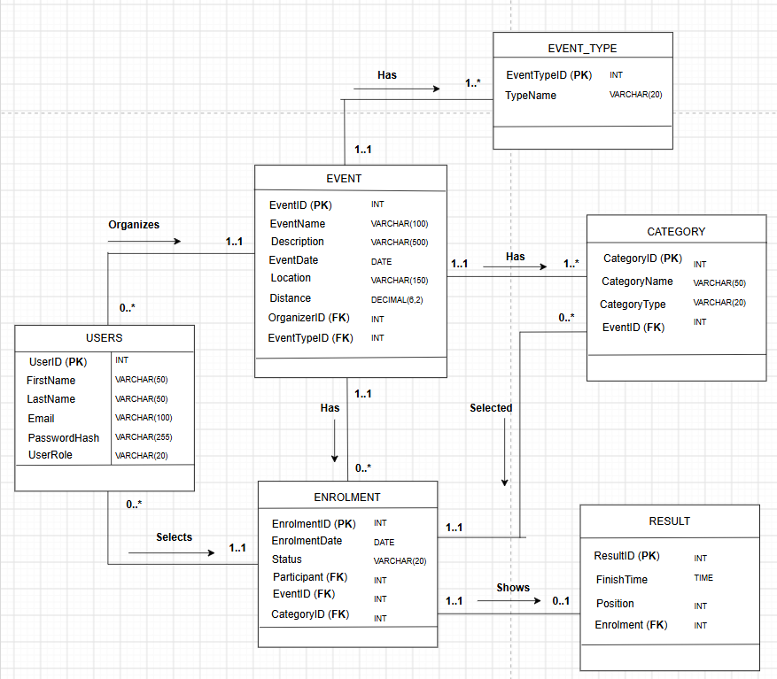
One organizer can organize zero or many events, while each event is organized by exactly one organizer.
One participant can have zero or many enrolments, while each enrolment belongs to exactly one participant.
One event can have zero or many enrolments, while each enrolment belongs to exactly one event.
One event has one or many categories, while each category belongs to exactly one event.
One category can be selected by zero or many participants/enrolments, while each enrolment selects exactly one category.
An enrolment may have no result yet, or one result, while each result belongs to exactly one enrolment.

